Project 2 Midpoint Report

Sarah Pierpoint and Melanie Vogt

October 13, 2026

Experiment
- Describe in your own words what experiments you conducted and how you conducted them. Be sure to include how many times you repeat each experiment to measure your run-time results.
- Describe the experimental environment, i.e., the machine on which you ran your experiment, including the number of CPUs and cores and the memory available
Environment Description
The experiments were run on the University of West Florida Computer Science Department’s Linux server (cs-ssh.uwf.edu). It is a VMware virtual machine with 48 virtual CPUs (Intel Xeon Gold 6338N at 2.20 GHz) and 125 GiB of memory. Because the machine is shared with other users, other running programs can affect timing, which is why each configuration was run multiple times.

Results
Provide the results from your experiments, including a visualized histogram of the Collatz stopping times and the time measurement results. Use a bar chart to visualize the time measurement results. The bar chart should visualize the runtime on the vertical axis vs threads on the horizontal axis.

The histogram was computed for N = 1,000,000, and the longest stopping time was 524. The distribution is a hump peaking around 100-120 with a long right tail.
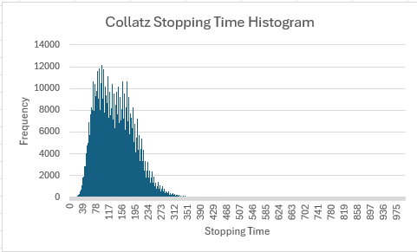

Discussion
Describe your analysis of the results, particularly the performance improvements that you observe as you use parallel computation via threading. Also, address the impact of the use of locks on the runtime of your program. Base your discussion on the results that you achieved.

Conclusions
Describe in one or two paragraphs the conclusions from the experiment. Be sure to discuss parallelism in relation to the CPU architecture that supports it, as well as the impact of locks in preventing race conditions.

